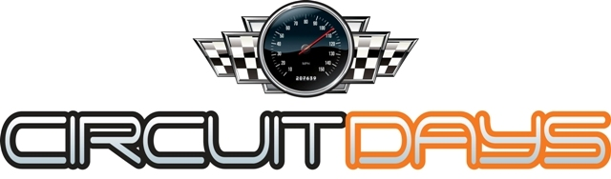

Circuit Days Ltd Track Day Declaration & Indemnity
I wish to drive cars and/or otherwise participate in the above event organised by Circuit Days Ltd.
I understand that motorsport and track day activity is hazardous and I am voluntarily exposing myself to risk of damage or loss or personal injury by participating in the track day.

Despite this I understand that racing is prohibited and that the purpose of the day is to allow the participants to improve their skills and learn the basic handling and braking characteristics of the cars which they are using.
I understand that any insurance carried by Circuit Days Ltd and/or the event location operator in respect of any liability which might arise out of the track day will be limited and that my own motor, third party and public liability insurance (if any) is unlikely to cover me for my losses, liabilities or personal injury. I also waive on behalf of myself and my successors, any claims in relation to the event, including for damages, injury or death sustained on the track and/or its facilities, against the event organisers or any other registered participant on the event.
I understand the following:-
- Circuit Days Ltd will not be scrutineering participants’ cars before permitting them on the circuit nor has it any control over the level of competence of other participants.
- Circuit Days Ltd is not a training organisation. Experienced track users and ARDS instructors will be in attendance to give guidance but it is just that - informal hints and tips.
- Circuit Days Ltd whilst giving guidance on, and where required to, enforcing the rules and safety standards of the event location operator will not otherwise enforce track discipline or safety measures. I myself am responsible for the way in which I use the track.
- That Circuit Days Ltd and/or the event location operator may refuse me access to the track if I or my car infringe any relevant rules or regulations or appear dangerous.
- The payment I have made to Circuit Days Ltd for the day is a track access charge only and is not refundable under any circumstances.
I declare:-
- That I am fit and healthy and that my eyesight (with lenses if to be worn) is adequate for track use.
- That any car for which I am responsible and/or which I will use on the track is in good and suitable mechanical condition.
- That I hold a current full licence entitling me to use on the public roads in the UK a car of the size and type that I will be using on the track.
- That I will not participate in the track day whilst under the influence of alcohol or intoxicating drugs.

I agree to make no claim against Circuit Days Ltd and/or the event location operator and/or their respective officers or agents in respect of any loss or injury suffered by me during the track day and to indemnify them against their costs and losses arising out of any claim made against them by anyone to the extent that such costs and losses are attributable directly or indirectly to my participation in the track day.
I have read and agree with the above Declaration and Indemnity and agree that its terms will also apply to my participation in any future track day organised by Circuit Days Ltd unless I sign a subsequent Declaration and Indemnity which will then take precedence.
Full Name | .
Signature | .
Address | .
Venue Name and Date
Emergency Contact Name & Number | .

